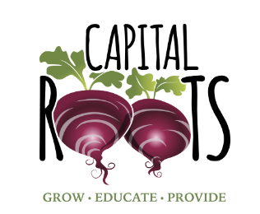

**Capital Roots Usability Test Report**

Rensselaer Polytechnic Institute

Introduction to Human Computer Interaction

Zoha Ahmed

**Abstract**

This study looks at the usability of the Capital Roots website, which aims to help with healthy nutrition through various programs. We noticed that parts of the website were difficult to read and finding specific pieces of information was challenging, which could make people less likely to visit the site. We surveyed 25 users about their opinion of the website and our main areas of focus were to improve readability and navigation. We suggested some changes such as making the homepage easier to understand, using better fonts, and rearranging things so everything is easier to find. These changes should help make the Capital Roots website more welcoming and easier for everyone to use.

**Introduction**

The Capital Roots website is a platform dedicated to a community that is good nutrition. While the website design is effective and gets across information well, there are some flaws in the design. Recognizing the importance of a user-friendly website, especially for a nonprofit website that is reliant on volunteers, this study was done to evaluate and redesign parts of the website, making sure that it was both doable and maintainable. We created a detailed survey to find out what people first thought when they visited the website, what problems they had when looking for information, and how they felt about using the site overall. Our study tested the idea that adding a search feature and organizing information more effectively, could improve user satisfaction and find their way around the website more easily. This paper explains how we collected and looked at feedback from users, what we learned from the survey, and the changes we suggest to make the Capital Roots website easier to use, read, and navigate.

**Research Goals**

For this project, we prioritized key areas of the website based on our research goals. We opted for a survey as the most efficient method to gather the necessary data. Our research questions focused on the following areas:

1. What aspects of the site keep the users engaged?
2. In what ways can the site’s readability be improved?
3. How long did it take users to navigate to specific pages on the website given its numerous links and extensive information?

We hypothesized that a search bar would reduce the amount of time it takes for a user to find a specific page on the website, as well as discoverability. Our main focus areas were navigation and readability since we noticed that on the website, some particular areas did not have easily readable text, the usability of clickable icons, or discoverability.

In our survey, we had a list of questions in various forms, and our main goal was to see if our participants were able to find certain pages of the website in a short amount of time. We gathered the demographics, and while our testing was limited to students, professors, and faculty at school, we recognize that the actual demographic of those who use the Capital Roots website is much wider in range and also likely biased towards those who are interested in volunteering, specifically in farming and gardening. We also added a section that asked whether or not the survey participant was experienced in web design or not, as that was also important to note when it came to their feedback. Those who do have experience with web design may see something that professionals can see, while those who don’t may point out something that web designers may not see, as sometimes designing becomes very technical and discounts users. We wanted opinions from both sides to improve this website to be accessible and usable for every single type of user. We then followed up with various questions about the actual website, allowing users to explore and directing users to different parts. In some cases, we asked users to locate specific addresses or links, while in others, we inquired about their overall satisfaction with the website. The feedback highlighted issues with the site's design principles, scale and proportions, and confusing hierarchies.

Our expectations when it came to the survey results were that it was difficult to navigate the Capital Roots website as it is a large website that has so much information that is not grouped very efficiently. For example, in one of our survey questions, we asked the user to find the link to support and donate to the incubator kitchen, and without a search bar, it was hard to find where that specific link was. It took two subsections of the website and a very long scroll to find this information and we expected that users would take a while to find this, or just give up when it takes more than a few seconds. This would cause problems as if navigating and finding resources on this website is difficult, it would discourage users from using this website to either find information or become less active. Because Capital Roots is a nonprofit that relies on proactive volunteers and donors, it’s important to keep users engaged, and having a difficult website would decrease that. This was one of the many examples of pages that required action not being able to be found easily, which prompted one of the main research goals we had in mind to improve navigation.

Our other main area of focus was readability and design, and we realized there were several pages where the text was not clear or covered up by a picture. The reason why this was a major area of focus for us is because this occurs on the home page, with the carousel of images The links on the images were broken and the image was cropped so that the entirety of the text could not be seen. Because this is also the home page of the website, it discourages users to continue using it as it’s seen as unprofessional or sloppy, even if the rest of the website doesn’t seem this way. Since first impressions are important, we need to improve on this. Going off of this, we also realized there were some pages where the buttons had color schemes that made texts hard to read.

**Business Values**

The UI/UX changes that we made for the Capital Roots website are rooted in a strategic alignment with the organization's commitment to fostering healthy communities through sustainable agriculture and nutrition education. Our research and resulting recommendations for the UI/UX are designed to deliver benefits across many dimensions of business and social value. By simplifying navigation and improving accessibility, we believe an increase in the time spent on the site will directly contribute to higher user engagement levels.

The recommended modifications, especially the addition of a search function and clearer calls to action, are aimed at helping the user go from an information seeker just browsing the website, to an active participant, whether as a volunteer, donor, or community member, potentially boosting engagement rates. By improving the overall usability of the website, Capital Roots can extend its reach to a broader audience, including those with varying levels of digital literacy, expanding its impact on community health as well as well-being. The clearer presentation of information and resources supports the organization's educational goals, giving users the knowledge to make informed decisions about sustainable practices and nutrition.

The implementation of a more structured feedback loop through the website can provide valuable insights into user behavior and preferences, informing future enhancements and strategic decisions. By facilitating access to resources and information on sustainable farming and healthy eating, the website redesign directly supports Capital Roots' mission to reduce the impact of poor nutrition on public health in New York’s Capital Region, potentially leading to long-term improvements in public health metrics. In conclusion, the UI/UX improvements of the Capital Roots website are not just about aesthetics or functionality, they are strategic investments in the organization's digital presence that will help amplify its mission and make a meaningful social impact.

**Methodologies**

Our methodology for testing the Capital Roots website involved a survey designed to gather feedback on various aspects of the site and the users' experiences. We surveyed 25 users across two iterations to obtain comprehensive insights. A website should be accessible and easy to use for everyone regardless of their attributes/ differences, such as age or experience on the internet. With this in mind, our ideal test group of who we wanted to fill out the survey was anyone and everyone, thus we sent the form out to all connections we had on campus in which anybody who would be willing to take the time out of their day to take the survey could take it. This opened our responses to come from people of different majors, ages, class years, and so on.

Our approach to evaluating the functionality and user experience of the Capital Roots website was centered around creating a survey designed to gauge participants' interactions across various aspects of the site. The essence of a successful website lies in its accessibility and user-friendliness, irrespective of individual differences users may have such as age or level of internet proficiency. With this in mind, we sought to cast a wide net for our test group, aiming to get a diverse array of perspectives and backgrounds.

To ensure inclusivity and diversity in our data pool, we extended the survey to all our team members’ connections within the RPI campus community. This inclusive outreach strategy allowed us to engage individuals from different majors, ages, class years, and so on. By reaching out to such a broad spectrum of people, we were able to capture a comprehensive range of insights and opinions regarding the Capital Roots website.

In executing this methodology, we recognized the important value of gathering feedback from a diverse group of users. The varied experiences and perspectives brought forth by participants with different backgrounds enriched the depth of our analysis. We went through multiple iterations of the wireframes to make it more effective based on the feedback we got from the survey.

**Key Learnings**

Our results are based on one survey that has 3 short answer questions and multiple choice questions. We started by asking multiple choice questions regarding the role of each person filling out the form: student, professor, and staff/admin. The results show:

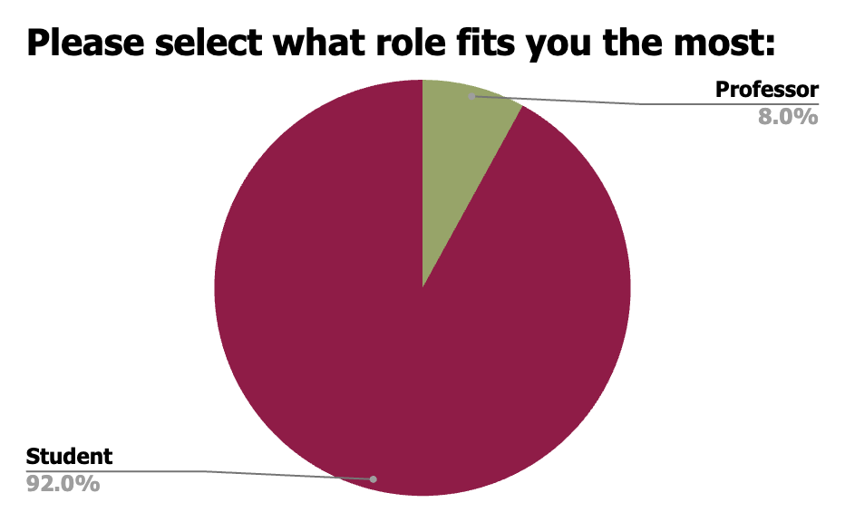

The next data point that is significant to this study is if the user has any experience with graphic design concepts or UI/UX elements. To gather this data, the users filled out a multiple choice question as well answering ‘yes’ or ‘no’. According to the results, the majority of the users are familiar with web design as follows:

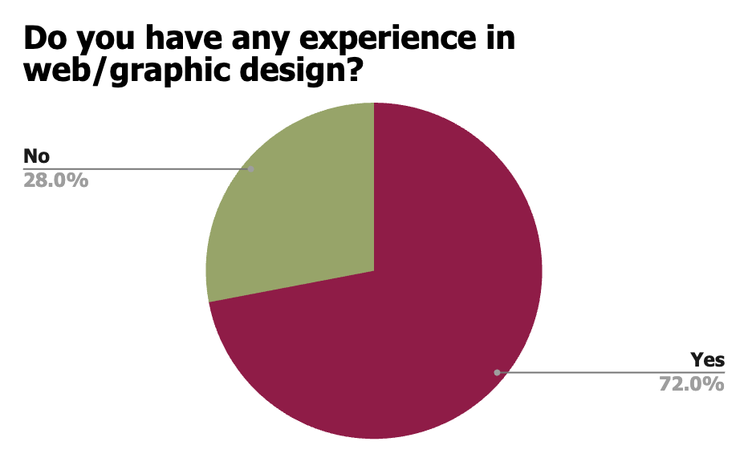

The next question the users were prompted with was another multiple-choice question that queried the users on what steps they first took once reaching the Capital Roots website. They were prompted with the following choices:

* Scroll down to read more
* Click on the image/text carousel
* Click on one of the banner tabs (What we do, Who we are, etc.)

These results were pretty split with the users all taking different steps when landing on the website as shown below:

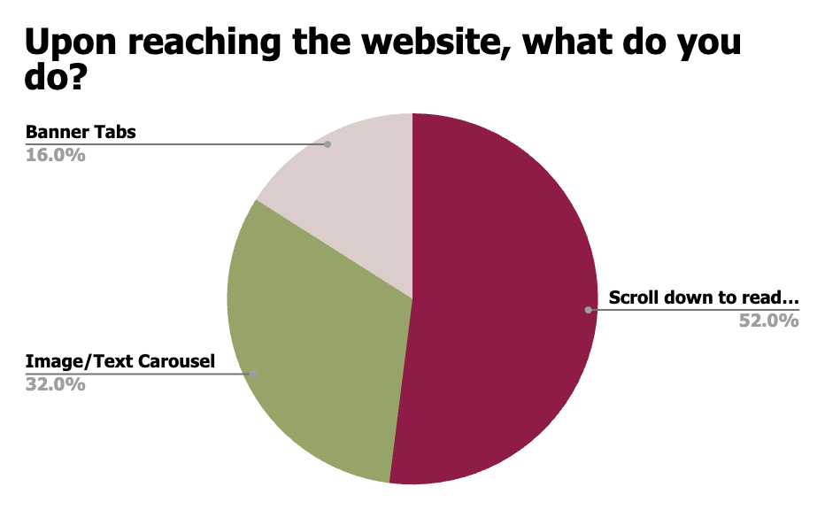

Once the users were more familiar with the website, the next few questions were open-ended and offered more insight about how the users were able to find certain information on the website such as the main mission and how long it took to find a specific page. A sample of results are as follows:

| **Question** | **Result** |
| --- | --- |
| What seems like the main mission/message of Capital Roots? And where did you find this?  If you don't have an answer, please enter N/A. | * “N/A” * “Something about reducing the impact of poor nutrition. If I scroll down a little, I see a huge paragraph and those specific words are put in italics, so I assume it's what they want us to remember.” * “Reduce impact of poor nutrition in public health” * “Healthy food” * “Capital Roots focuses on nourishing communities and combatting poor nutrition by organizing community gardens, providing healthy food access, offering nutritional and horticultural education for all ages and coordinating urban greening programs. * I found this on the home page and also under Our Purpose.” * “Being able to supply areas with green fresh food that’s adorable. I found it on the first scroll down under food access” * “mission: very person has access to fresh, healthy food; found on home banner” * “Providing healthy food to the local region” * “Access to healthy and affordable food” * “provide food awareness and support in Capital communities” * "Reduce the impact of poor nutrition on public health in New York’s Capital Region" - Main Place’ * “Advertising for nutritional food” * “Grow plants and educate people. Found it in the logo” |
| Approximately how long does it take to find the page with the link to "Support Incubator Kitchens" (pictured ? If you were not able to find it, enter N/A. | * <1 minute * 2-3 minutes * About 4-5 minutes * N/A (6 responses) |

Following how familiar and easy it was to use the website, the users were further questioned on finding specific aspects of the site that are important such as the address of Capital Roots. The correct address of Capital Roots is 594 River Street, so the majority of the users were able to find the correct address, but there were some discrepancies. To test how accessible the address and banner tabs were on the website the users were prompted with these multiple-choice questions and prompts:

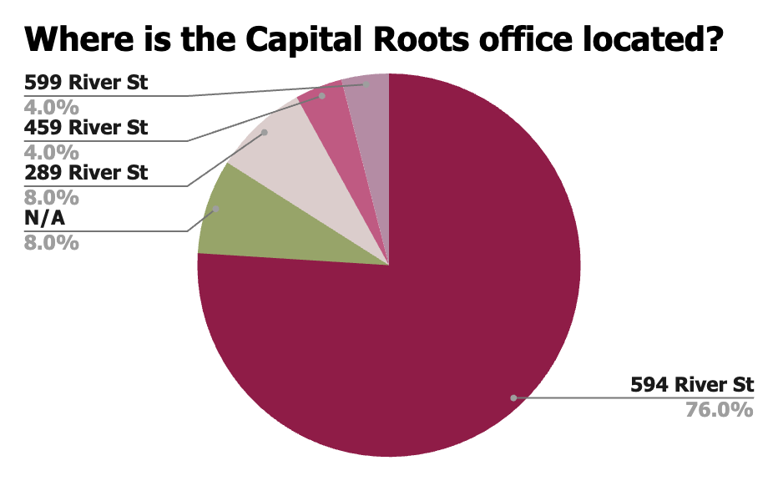

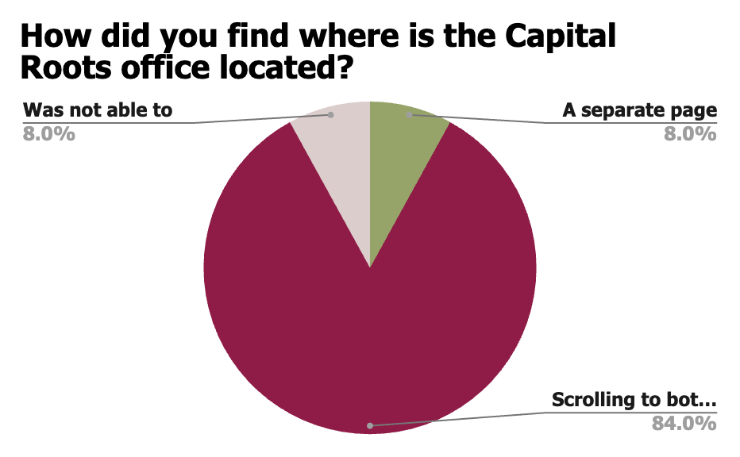

To see how accessible information on the carousel on the landing page was, the users were prompted with a multiple choice question with either a ‘yes’ or ‘no’ if they were able to see the details of an event. Similarly, testing how easy the website navigation was for users, they were prompted with a question that was answered on a scale from 1-5, 1 being easy and 5 being very difficult to find. The results are as follows:

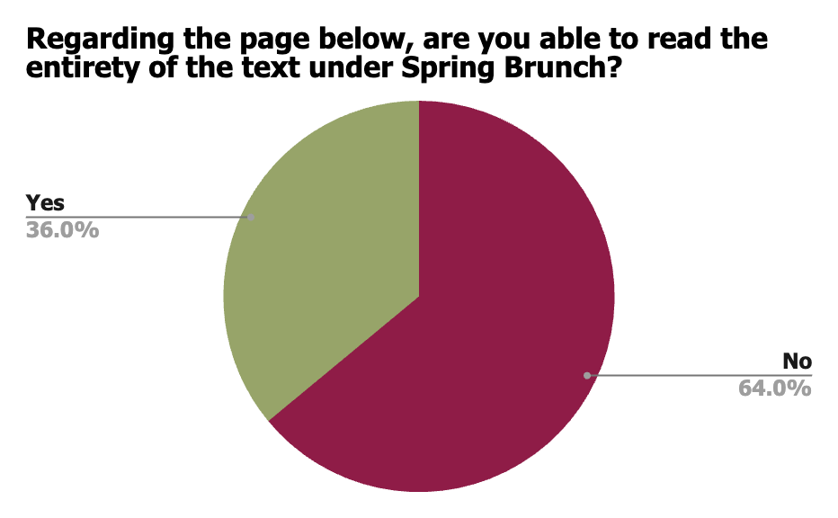

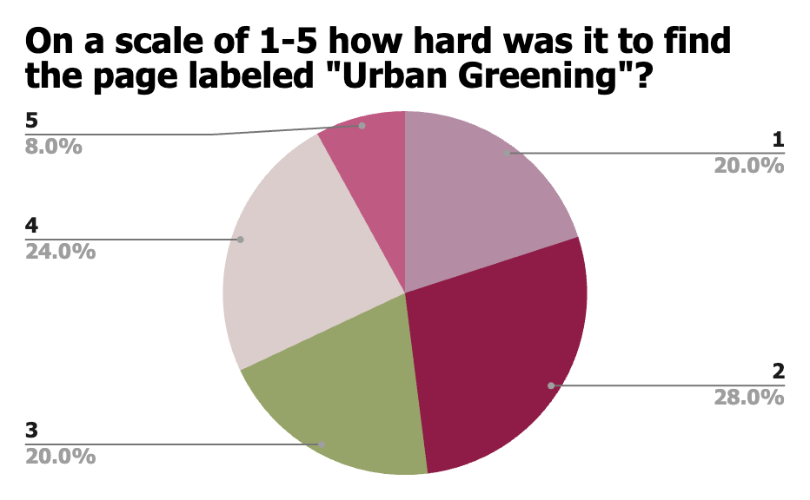

To conclude the survey, the users were prompted with an open-ended question for any suggestions or areas the website can use to make navigating easier. Some results are as follows:

| **Are there any suggestions you have to make navigation of this site easier/more efficient?** | * “There is a lot of not knowing what we don't know with this site, which makes me more inclined to just give up rather than go looking for things.” * “There too many options for what we do. Be nice to have a search bar. the text is being covered in the banner.” * “Less options on the dropdown or the ability to scroll” * “The homepage could be more mobile friendly by not having a lot of information to scroll through” * “i feel like there’s too much going on in the landing page make it more simplified and concise” |
| --- | --- |

For the discussion section, we aim to look deeper into the usability issues and provide possible solutions for Capital Roots to improve their website. Therefore, we start by inquiring into the following matters:

What usability issues are the **most irritating**?

What usability issues occur **most frequently**?

What usability issues should be **prioritized**?

These questions cannot be answered without closely examining the users’ experiences during the testing process. Therefore, we implemented our wireframes with possible changes that can be made to the website. Starting with the carousel on the landing page, we redesigned it so that the details for the Spring Brunch are not covered and instead, there is a button to learn more. Furthermore, the font is changed and the important details of the event are bolded and stand out more to the user. The ‘Resources’ page does not provide any information except that the page is under construction, but with our new design, the users are now aware that they can learn more about the page if they use one of the dropdowns on the banner. We also decided there was an alternative and more technical way to do this, where since we know the website is hosted on WordPress, we could turn off the Resources page entirely so users will not have to face pages that are not fully developed. For the dropdown sections that have a lot of content, the banner covers parts of the page and many users have complained about being unable to scroll, so with our new design the users will be able to see all information since the content won’t be right under where the dropdown is located. One of the biggest suggestions from the users was changing the fonts and some display elements to enhance the website while still maintaining its theme. Our design uses bold, different fonts, and a button to learn more with colors that contrast each other rather than blend out. Overall, based on the users' results, our designs cater to their needs to ensure better and more efficient navigation on the Capitol Roots website.

**Recommendations**

After gathering our results from our methodologies and creating the wireframes displayed, we have several recommendations to the client. We recommend making the application more cohesive and refined by making the text size a consistent larger size and a different color which would make it more readable. This new standardization would highlight the information and greatly improve the user’s overall experience. In addition to this, we recommend that the client add a search bar to improve the navigation between the pages of the application. This also would increase the simplicity and cohesiveness of the application as we could then reduce the number of sections that are available in the drop-down menu of the header. Apart from these, we also recommend spacing information out on pages so the users will be able to see everything equally and not get confused. Overall, all of these small changes we recommend will greatly improve the user’s experience as it minimizes confusion, increases the potential for easier access to information, and allows for main ideas to stand out. For the client, it would be most beneficial with minimal maintenance to make these changes on the website, as these changes are mainly a different graphic design.

|  |  |
| --- | --- |
|  |  |
|  |  |
|  |  |

**References**

Mike DellaRocco. (n.d.). *Our mission is to nourish healthy communities by providing*. Capital

Roots. <https://www.capitalroots.org/>